MASCHERPA Audric ROB 3 2022 / 2023

**POLY-SNAKE**

**Weekly report n°21 from 17/04/23 :**

Following the last session, I continued to work on the wiring of the PolySnake project. I was particularly interested in the connections between the servomotors and the pins of the Arduino board in order to be able to control them using the program we developed with my partner.

link : <https://github.com/YOUSSNDR/PolySnake/tree/main/programmes>

So to do this I just welded the orange cable to a male output in order to be able to connect the servomotor to the Arduino card as in figure 21.1.

Figure 21.1

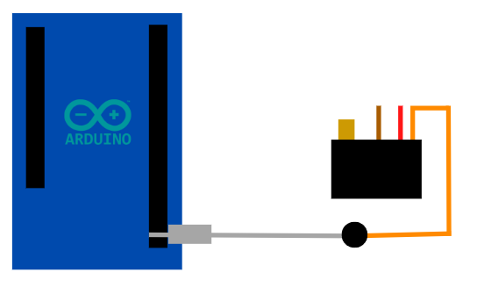

After repeating this operation with all the servomotors, here is the visual result in figure 21.2.1 and 21.2.2.

Figure 21.2.1

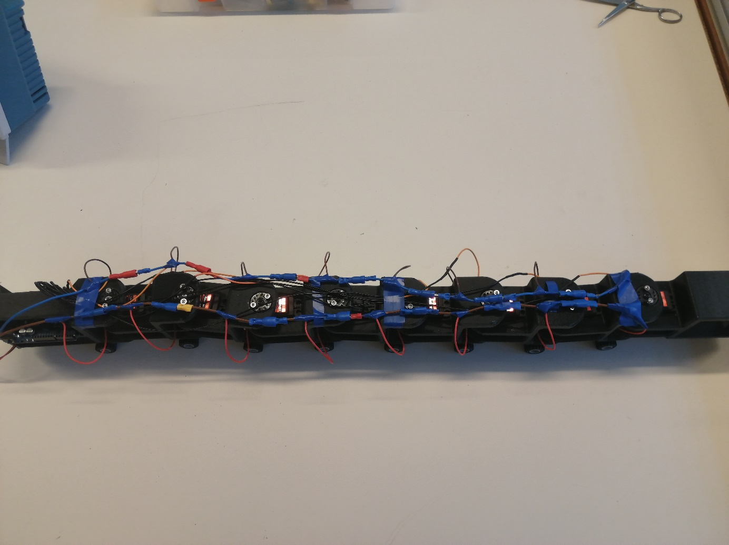

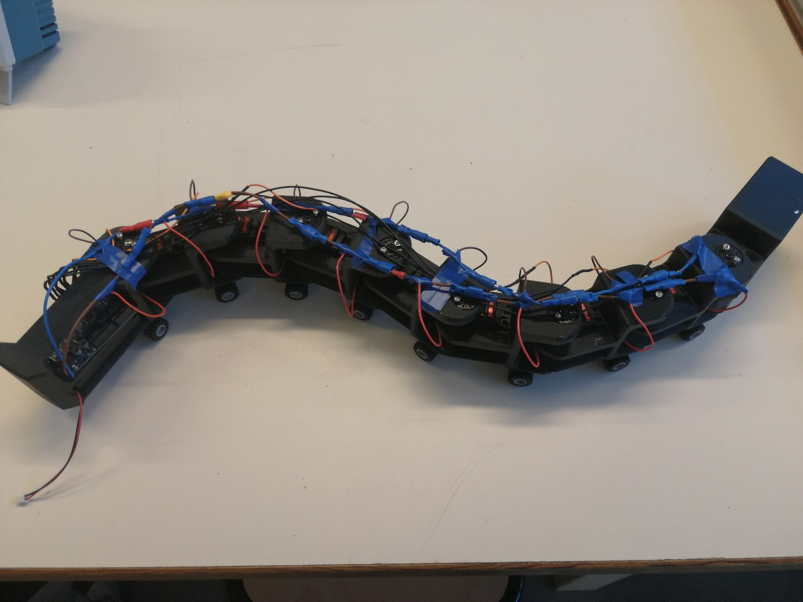

Figure 21.2.2

After starting to test a basic program on each servomotor to check their proper functioning and the condition of all the welds, it appears that out of the 8 servomotors, 1 seems not to be powered and 2 others are connected to the same pin.

The next session will therefore be devoted to solving these problems in order to finally allow our snake to be able to operate without an external power supply.